|  |  |  |  |  |
| --- | --- | --- | --- | --- |
| ****Name**** | ****Football**** | ****Hockey**** | ****Basketball**** | ****Netball**** |
| ****Robert**** | ****Yes**** | ****Yes**** | ****No**** | ****No**** |
| ****James**** | ****Yes**** | ****Yes**** | ****No**** | ****No**** |
| ****John**** | ****Yes**** | ****No**** | ****No**** | ****NO**** |
| ****Mary**** | ****Yes**** | ****No**** | ****Yes**** | ****Yes**** |
| ****Jennifer**** | ****Yes**** | ****No**** | ****No**** | ****No**** |
| ****William**** | ****Yes**** | ****Yes**** | ****Yes**** | ****Yes**** |
| ****Linda**** | ****No**** | ****Yes**** | ****Yes**** | ****Yes**** |
| ****Elizabeth**** | ****No**** | ****Yes**** | ****No**** | ****Yes**** |
| ****Daniel**** | ****No**** | ****No**** | ****Yes**** | ****No**** |
| ****Jessica**** | ****No**** | ****No**** | ****No**** | ****Yes**** |
| ****Anthony**** | ****No**** | ****No**** | ****No**** | ****Yes**** |
| ****Jayne**** | ****No**** | ****No**** | ****Yes**** | ****No**** |
| ****Dorothy**** | ****No**** | ****No**** | ****No**** | ****No**** |

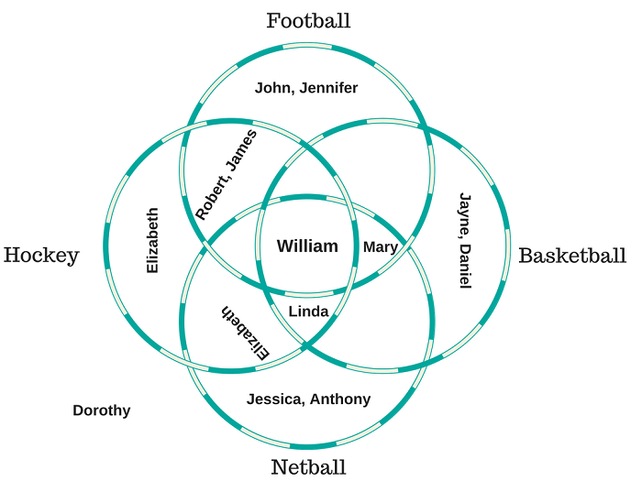

**Q8.** What is the most interesting thing you learned from your Venn diagram? And how would you describe this knowledge using SQL set operations and/or joins?

**A8.** This venn diagram informed me that, William takes part in all the sports available, the results would be described as Hockey INTERSECT Netball INTERSECT Basketball INTERSECT Football

**Q7.**SQL Join Operation - FULL: Using any two or more of the data sets in your Venn diagram, how would you describe the results of a full join?

**A7.** I choose Football and Netball. A full join will return; Jessica, Anthony, Elizabeth, Linda, William, Mary, Robert, James, John and Jennifer.

**Q6.** SQL Join Operation - RIGHT: Using any two of the data sets in your Venn diagram, how would you describe the results of a right join?

**A6.** I choose Hockey and Basketball datasets, a right join in this case will include; William, Linda, Mary, Daniel and Jayne.

**Q1.** SQL Set Operation UNION: Choose any two or more of the data sets in your Venn diagram. Which elements would be included in the union of those data sets?

**A1.** I choose Hockey and Netball, the union of these two datasets is; Jessica, Anthony, Elizabeth, Linda, William, Mary, Robert and James.

****Q5:****SQL Join Operation - LEFT: Using any two of the data sets in your Venn diagram, how would you describe the results of a left join?

**A5.** I choose Football & Hockey datasets for left join; Elizabeth, Robert, James, William and Linda.

****Q2:****SQL Set Operation INTERSECT: How would you describe one segment of your Venn diagram that represents the intersection of at least three of your data sets?

**A2.** The answer to this is; Linda takes part in Hockey, Netball and also takes part in Basketball as well.